

**BHARTIYAVIDYABHAVAN’S**

**M.M.COLLEGEOFARTS,N.M.INSTITUTEOFSCIENCE**

**H.R.J.COLLEGEOFCOMMERCE BHAVAN’SCOLLEGE**

**MUNSHINAGAR,ANDHERIWEST,**

**MUMBAI-400058**

**CERTIFICATE**

This is to certify that Ms. Sanjana Sharma Seatno.TYIT46 of TYBSc. Information Technology has satisfactorily completed the practical course in Enterprise Java And Spring as prescribed by the University of Mumbai during the academic year 2023-2024.

Internal Examiner External Examiner

Signature Signature

Co-Ordinator Signature College Stamp

**INDEX**

|  |  |  |  |
| --- | --- | --- | --- |
| Practical No. | Date | Practical Name | Sign |
|  | 23/06/2023 | Create a simple calculator application using servlet |  |
|  | 23/06/2023 | Create a login form using servlet if the username and password are correct then it says message “ hello <username>“ else a message “Login Failed” |  |
|  | 23/06/2023 | Create a registration form Servlet in java using JDBC . Accept the details such as username,password,email and country from the user using HTML form and store the registration details in the database |  |
|  | 11/07/2023 | Using Request Dispatcher Interface . Create a servlet which will validate the password entered by the user if the user has entered “Servlet” as Password , then he will be forwarded to Welcome Servlet else the user will stay on the index.html page and an error message will be displayed. |  |
|  | 25/07/2023 | Create a servlet that uses Cookies to store the number of times a user has visited servlet |  |
|  | 10/07/2023 | Create a servlet demonstrating the use of session creation and destruction. Also check whether the user has visited this page first time or has visited earlier also using sessions. |  |
|  | 01/08/2023 | Develop Simple Servlet Question Answer Application using Database. |  |
|  | 01/08/2023 | Create a registration and login JSP application to register and authenticate the user based on username and password using JDBC. |  |
|  | 08/08/2023 | Develop a simple JSP application to pass values from one page to another |  |
|  | 22/08/2023 | Create a servlet that updates the Employee record using database |  |
|  | 22/08/2023 | Create a JSP application to demonstrate the use of expression language |  |
|  | 22/08/2023 | Create a JSP application to demonstrate the use of JSTL(for each) |  |
|  | 12/09/2023 | Create a calculator using EJB |  |
|  | 12/09/2023 | Create a Currency Converter Application using EJB |  |
|  | 12/09/2023 | Develop a simple room reservation system using EJB |  |
|  | 14/09/2023 | Develop a JPA Application to demonstrate use of ORM associations. |  |
|  | 26/09/2023 | Develop a simple application using hibernate |  |

**Practical 1 :- Creating a Simple Calculator Application using Servlet.**

Index.html

<!DOCTYPE html>

<html>

<head>

<title>Calculator</title>

<meta charset="UTF-8">

<meta name="viewport" content="width=device-width, initial-scale=1.0">

<style>

form{text-align: center;

font-size: 12px;

background-color: yellowgreen;

border: 2px solid}

</style>

</head>

<body>

<dV>

<center><h1> Calculator</h1></center>

<form<form action="cal" method="get"><b>

Enter first number:<input type="number" name="first"><br><br>

Enter second number:<input type="number" name="second"><br><br>

Operation:-

<select name="operation" id="operation">

<option value="Add"> +</option>

<option value="subtract"> - </option>

<option value="Multiply"> * </option>

<option value="DVide"> /</option>

</select><br><br>

<input type="submit" value="submit">

</b>

</form>

</dV>

</body>

</html>

**Cal.java**

import java.io.IOException;

import java.io.PrintWriter;

import javax.servlet.ServletException;

import javax.servlet.annotation.WebServlet;

import javax.servlet.http.HttpServlet;

import javax.servlet.http.HttpServletRequest;

import javax.servlet.http.HttpServletResponse;

@WebServlet(urlPatterns = {"/MyServlet"})

public class MyServlet extends HttpServlet {

protected void processRequest(HttpServletRequest request, HttpServletResponse response)

throws ServletException, IOException {

response.setContentType("text/html;charset=UTF-8");

try (PrintWriter out = response.getWriter()) {

out.println("<!DOCTYPE html>");

out.println("<html>");

out.println("<head>");

out.println("<title>Servlet MyServlet</title>");

out.println("</head>");

out.println("<body>");

int a=Integer.parseInt(request.getParameter("t1"));

int b=Integer.parseInt(request.getParameter("t2"));

int opt=Integer.parseInt(request.getParameter("t3"));

switch(opt){

case 1:

out.println("<h1>Addition of two numbers are: " +(a+b)+"</h1>");

break;

case 2:

out.println("<h1>DVision of two numbers are: " +(a/b)+"</h1>");

break;

case 3:

out.println("<h1>Multiplication of two numbers are: " +(a*b)+"</h1>");

break;

case 4:

out.println("<h1>Subtration of two numbers are: " +(a-b)+"</h1>");

}

out.println("</body>");

out.println("</html>");

} } @Override

protected void doGet(HttpServletRequest request, HttpServletResponse response)

throws ServletException, IOException {

processRequest(request, response);

}@Override

protected void doPost(HttpServletRequest request, HttpServletResponse response)

throws ServletException, IOException {

processRequest(request, response);

}@Override

public String getServletInfo() {

return "Short description";

}}

**Output:**

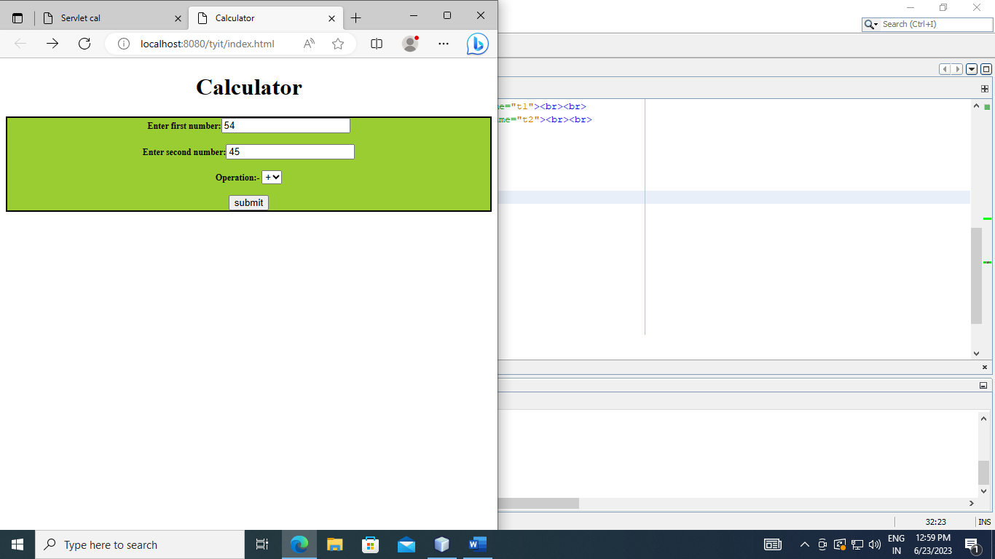

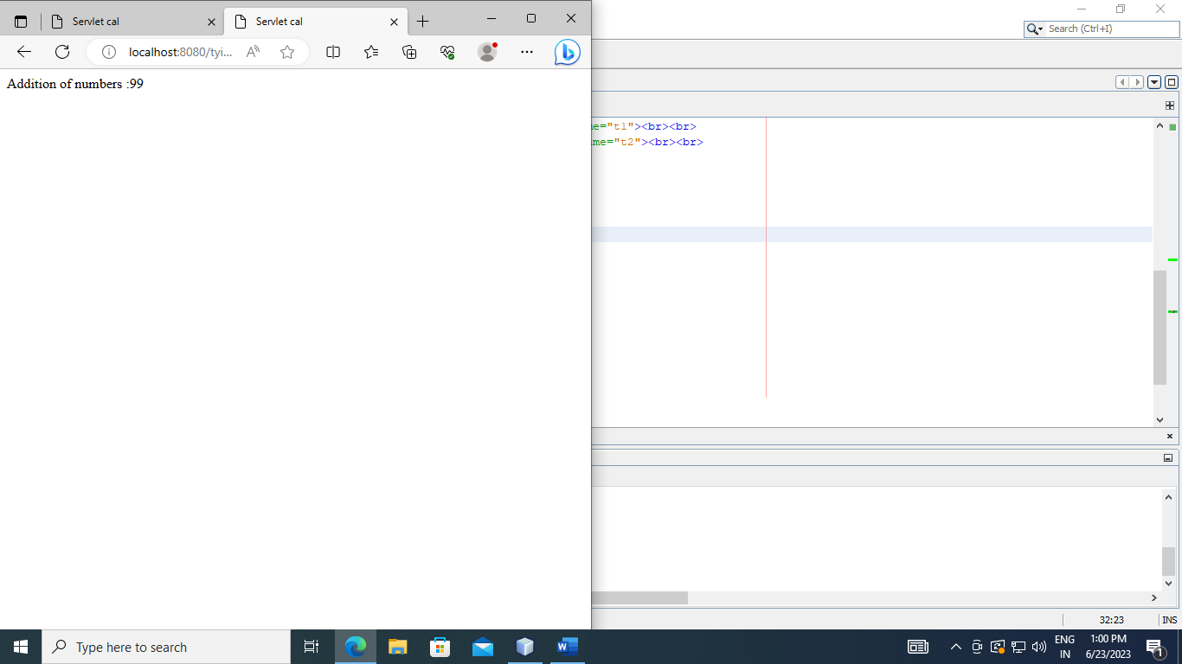

**Practical 2:- Create a Servlet for a Login Page .**

**Index.html**

<!DOCTYPE html>

<html>

<head>

<title> Login Page </title>

<meta charset="UTF-8">

<meta name="viewport" content="width=device-width, initial-scale=1.0">

<style>

form{

text-align: center;

background-color: yellow;

border: 2px solid;

}

</style>

</head>

<body>

<form action="Login" method="get">

Username :<input type="text" placeholder="Enter Username" name="username" required> </br> </br>

Password :<input type="password" placeholder="Enter Password" name="password" required> </br> </br>

<input type="checkbox" checked="checked"> Remember me </br> <br>

<button type="submit">Login</button>

<button type="button" class="cancelbtn"> Cancel</button> </br> <br>

Forgot <a href="#"> password? </a>

</form>

</body>

</html>

**Login.java**

import java.io.IOException;

import java.io.PrintWriter;

import javax.servlet.ServletException;

import javax.servlet.http.HttpServlet;

import javax.servlet.http.HttpServletRequest;

import javax.servlet.http.HttpServletResponse;

public class NewServlet extends HttpServlet {

protected void processRequest(HttpServletRequest request, HttpServletResponse response)

throws ServletException, IOException {

response.setContentType("text/html;charset=UTF-8");

try (PrintWriter out = response.getWriter()) {

/* TODO output your page here. You may use following sample code. */

out.println("<!DOCTYPE html>");

out.println("<html>");

out.println("<head>");

out.println("<title>Servlet NewServlet</title>");

out.println("</head>");

out.println("<body>");

String a=request.getParameter("password");

String b=request.getParameter("Username");

if(a.equalsIgnoreCase("admin"))

{

out.println("<h1>Hello "+b+"</h1>");

}

else

{

out.println("<h2>Login failed!!</h2>");

}

out.println("</body>");

out.println("</html>");

} }

@Override

protected void doGet(HttpServletRequest request, HttpServletResponse response)

throws ServletException, IOException {

processRequest(request, response); }

@Override

protected void doPost(HttpServletRequest request, HttpServletResponse response)

throws ServletException, IOException {

processRequest(request, response);

}

@Override

public String getServletInfo() {

return "Short description";

}// </editor-fold>

}

**Output:-**

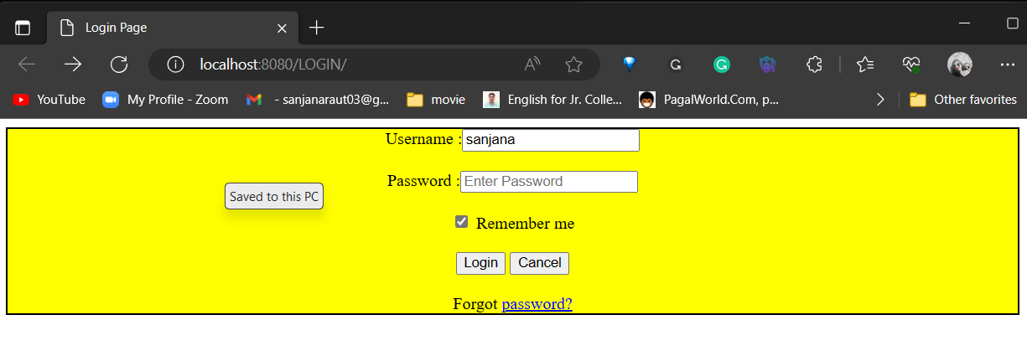

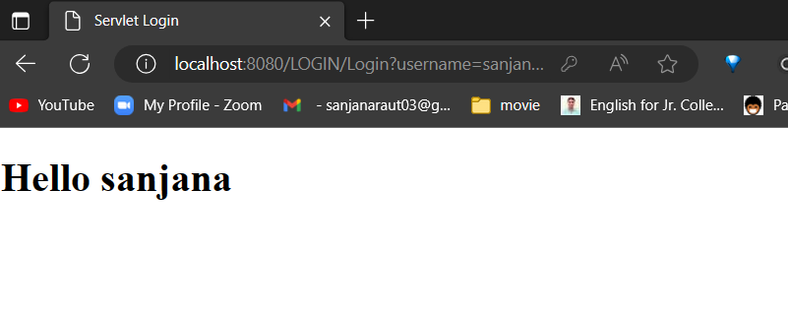

**Practical 03 :- Create a registration servlet in Java using JDBC**

**INDEX.HTML**

<!DOCTYPE html>

<html>

<head>

<title>Registration Form </title>

<meta charset="UTF-8">

<meta name="viewport" content="width=device-width, initial-scale=1.0">

<style>

form{

background-color: yellow;

border: 2px solid black }

</style> </head>

<body>

<center>

<form action="Servlet1" method="post">

<h1>REGISTRATION FORM</h1>

Name <input type ="text " name="t1" required > <br> <br>

Roll no. <input type ="password " name="t2" required > <br> <br>

Email <input type ="email " name="t3" required > <br> <br>

Password <input type ="password" name="t4" required > <br> <br>

<input type ="submit" value="Sign Up"/>

</form> </center>

</body></html>

**Servlet1.java**

import java.io.IOException;

import java.io.PrintWriter;

import java.sql.Connection;

import java.sql.DrVerManager;

import java.sql.SQLException;

import java.sql.Statement;

import java.util.logging.Level;

import java.util.logging.Logger;

import javax.servlet.ServletException;

import javax.servlet.http.HttpServlet;

import javax.servlet.http.HttpServletRequest;

import javax.servlet.http.HttpServletResponse;

protected void processRequest(HttpServletRequest request, HttpServletResponse response)

throws ServletException, IOException {

response.setContentType("text/html;charset=UTF-8");

try (PrintWriter out = response.getWriter()) {

/* TODO output your page here. You may use following sample code. */

out.println("<!DOCTYPE html>");

out.println("<html>");

out.println("<head>");

out.println("<title>Servlet Servlet1</title>");

out.println("</head>");

out.println("<body>");

//Declaring variables

String a= request.getParameter("t1");

int b = Integer.parseInt(request.getParameter("t2"));

String c= request.getParameter("t3");

String d= request.getParameter("t4");

out.println("<h1> NAME:" +a+"</h1>");

out.println("<h1> ROLL NO :" +b+"</h1>");

out.println("<h1> EMAIL:" +c+"</h1>");

out.println("<h1> PASSWORD:" +d+"</h1>");

//Execute query

String sql ="insert into COLLEGE values('"+a+"',"+b+",'"+c+"','"+d+"')";

out.println("<h1> Statement "+sql+"</h1>");

//create connection

Connection con = DrVerManager.getConnection("jdbc:derby://localhost:1527/bhavans", "bhavans", "bhavans");

out.println("<h1>Connected</h1>");

Statement st = con.createStatement();

st.executeUpdate(sql);

out.println("<h1>Record Added</h1>");

out.println("</body>");

out.println("</html>");

} catch (SQLException ex) {

Logger.getLogger(Servlet1.class.getName()).log(Level.SEVERE, null, ex);

}

} @Override

protected void doGet(HttpServletRequest request, HttpServletResponse response)

throws ServletException, IOException {

processRequest(request, response);

}

@Override

protected void doPost(HttpServletRequest request, HttpServletResponse response)

throws ServletException, IOException {

processRequest(request, response);

}

@Override

public String getServletInfo() {

return "Short description";

}// </editor-fold>

}

**Output:-**

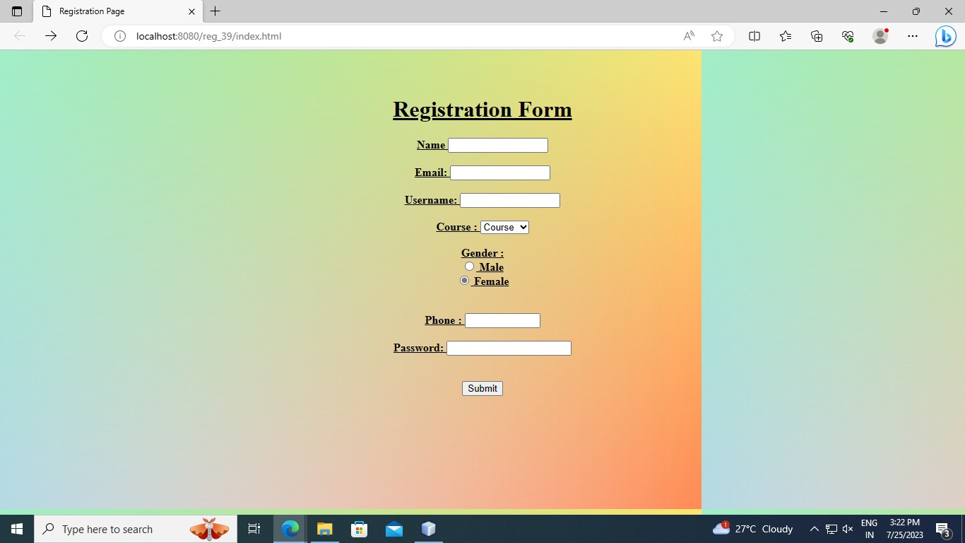

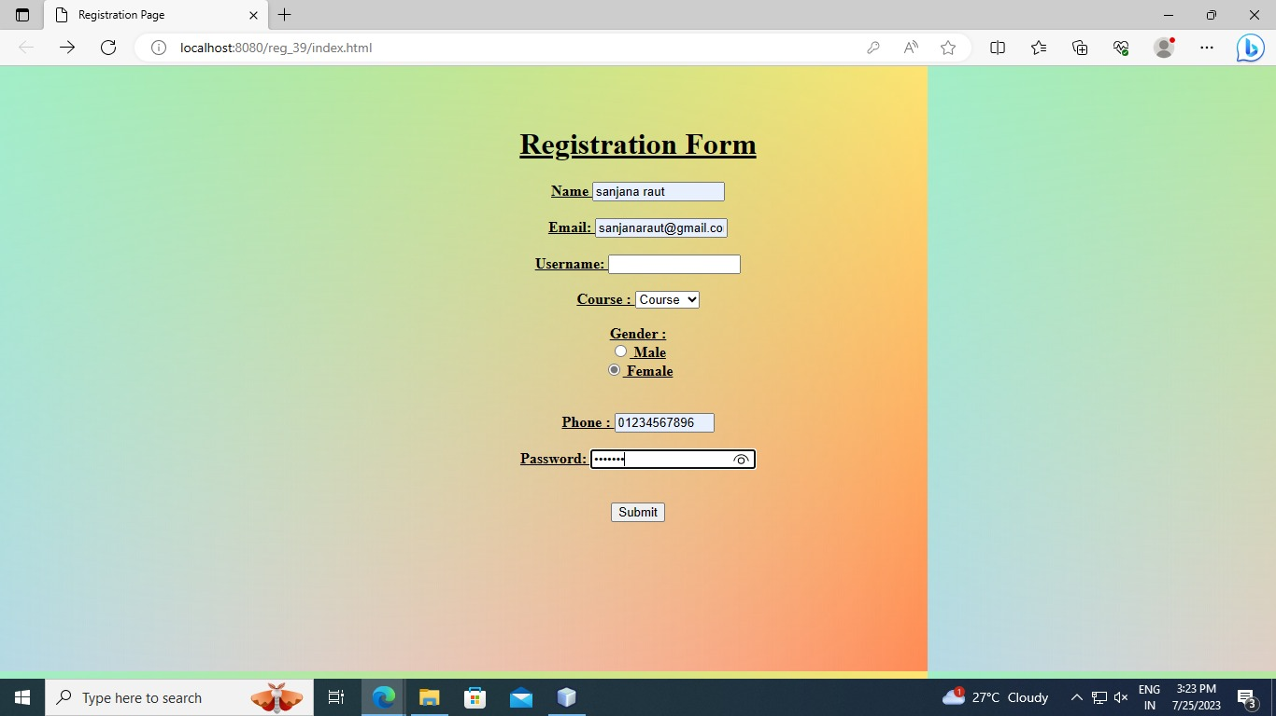

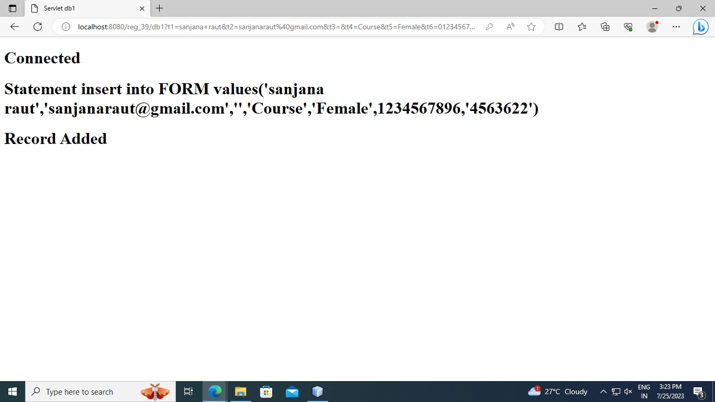

**Database**

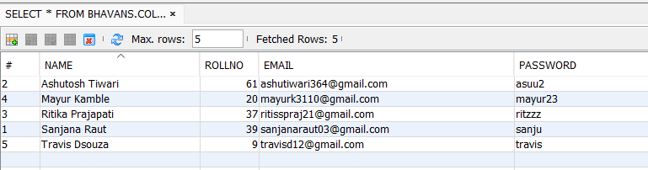

## **Practical 4 - Using Request Dispatcher Interface . Create a servlet which will validate the password entered by the user if the user has entered “servlet” as password , then he will be forwarded to Welcome Servlet else the user will stay on the index.html page and an error message will be displayed.**

### Index.html-

<html>

<head>

<title>TODO supply a title</title>

<meta charset="UTF-8">

<meta name="viewport" content="width=device-width, initial-scale=1.0">

</head>

<body>

<form action="loginD" method="post">

Name:<input type="text" name="userName"/><br/>

Password:<input type="password" name="userPass"/><br/>

<input type="submit" value="login"/>

</form>

</body>

</html>

### loginD.java –

import java.io.IOException;

import java.io.PrintWriter;

import javax.servlet.RequestDispatcher;

import javax.servlet.ServletException;

import javax.servlet.http.HttpServlet;

import javax.servlet.http.HttpServletRequest;

import javax.servlet.http.HttpServletResponse;

public class loginD extends HttpServlet {

protected void processRequest(HttpServletRequest request, HttpServletResponse response)

throws ServletException, IOException {

response.setContentType("text/html;charset=UTF-8");

try (PrintWriter out = response.getWriter()) {

out.println("<!DOCTYPE html>");

out.println("<html>");

out.println("<head>");

out.println("<title>Servlet loginD</title>");

out.println("</head>");

out.println("<body>");

String n=request.getParameter("userName");

String p=request.getParameter("userPass");

if(p.equals("servlet")){

RequestDispatcher rd=request.getRequestDispatcher("login2D");

rd.forward(request, response);

}

else{

out.print("Sorry UserName or Password Error!");

RequestDispatcher rd=request.getRequestDispatcher("/index.html");

rd.include(request, response);

}

out.println("</body>");

out.println("</html>");

}

}

### login2D.java –

import java.io.IOException;

import java.io.PrintWriter;

import javax.servlet.ServletException;

import javax.servlet.http.HttpServlet;

import javax.servlet.http.HttpServletRequest;

import javax.servlet.http.HttpServletResponse;

public class login2D extends HttpServlet {

protected void processRequest(HttpServletRequest request, HttpServletResponse response)

throws ServletException, IOException {

response.setContentType("text/html;charset=UTF-8");

try (PrintWriter out = response.getWriter()) {

out.println("<!DOCTYPE html>");

out.println("<html>");

out.println("<head>");

out.println("<title>Servlet login2D</title>");

out.println("</head>");

out.println("<body>");

String n=request.getParameter("userName");

out.print("Welcome "+n);

out.println("</body>");

out.println("</html>");

}

}

### Output-

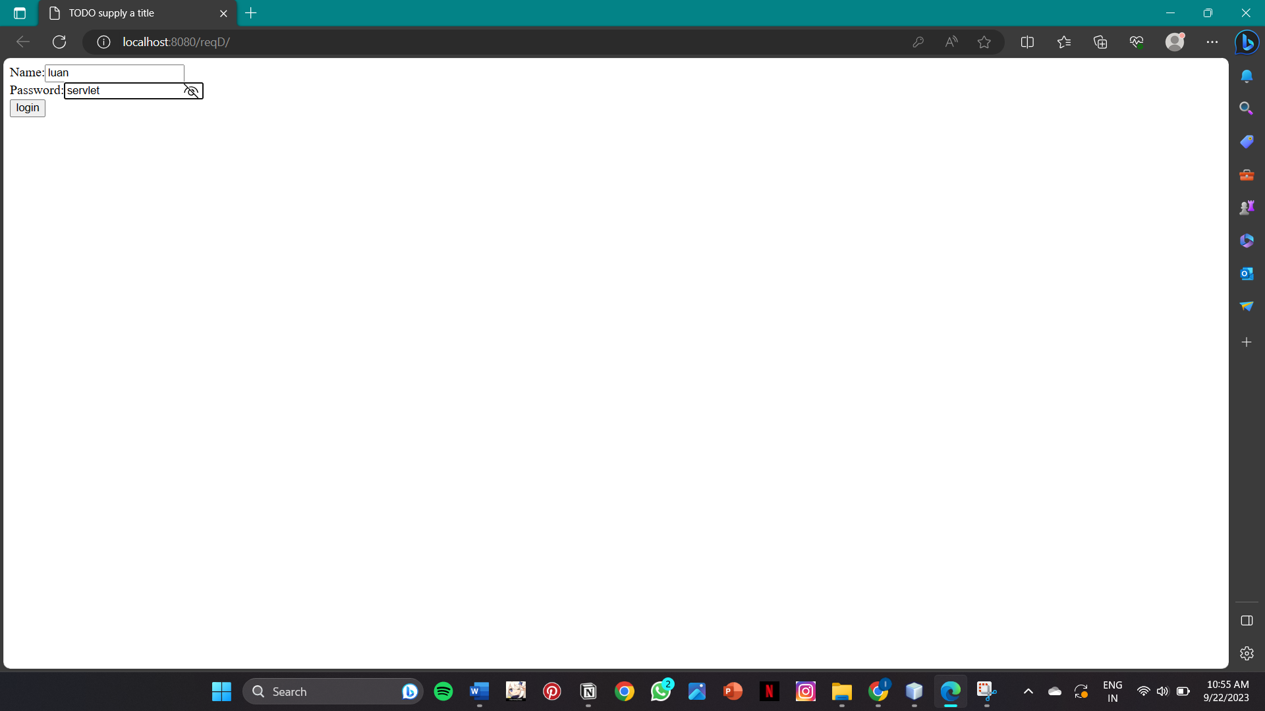

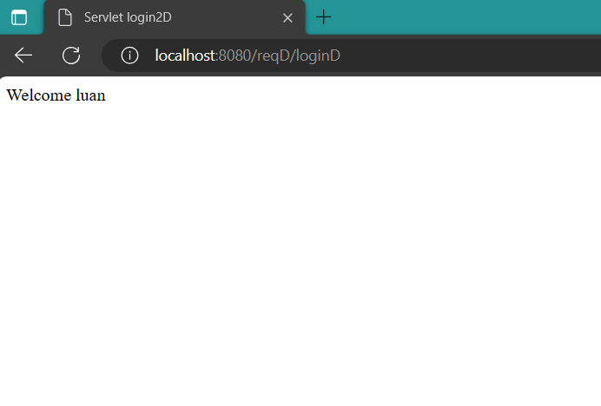

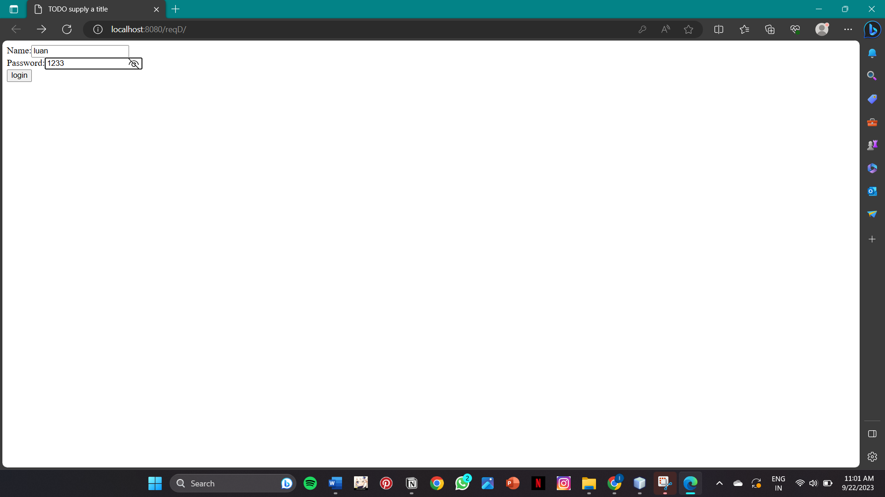

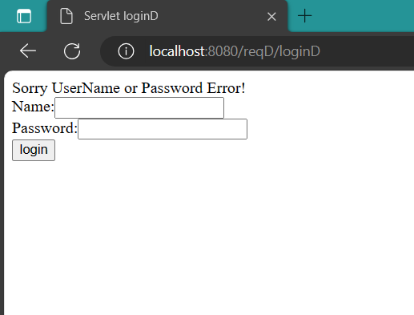

**Practical 5:- Create a servlet that uses Cookies to store the number of times a user has visited servlet.**

**Index.html**

<html>

<head>

<title>Cookies </title>

<meta charset="UTF-8">

<meta name="viewport" content="width=device-width, initial-scale=1.0">

</head>

<body>

<dV>TODO write content</dV>

</body>

</html>

**Ckservlet.java**

import java.io.IOException;

import java.io.PrintWriter;

import javax.servlet.ServletException;

import javax.servlet.http.Cookie;

import javax.servlet.http.HttpServlet;

import javax.servlet.http.HttpServletRequest;

import javax.servlet.http.HttpServletResponse;

public class NewServlet4 extends HttpServlet {

static int i=1;

protected void processRequest(HttpServletRequest request, HttpServletResponse response)

throws ServletException, IOException {

response.setContentType("text/html;charset=UTF-8");

try (PrintWriter out = response.getWriter()) {

/* TODO output your page here. You may use following sample code. */

out.println("<!DOCTYPE html>");

out.println("<html>");

out.println("<head>");

out.println("<title>Servlet NewServlet4</title>");

out.println("</head>");

out.println("<body>");

Cookie c=new Cookie("Visit",String.valueOf(i));

response.addCookie(c);

int j=Integer.parseInt(c.getValue());

if(j==1){

out.println("Welcome User");

}

else{

out.println("You have visited this website "+j+"times");

}

i++;

out.println("</body>");

out.println("</html>");

}

}

@Override

protected void doGet(HttpServletRequest request, HttpServletResponse response)

throws ServletException, IOException {

processRequest(request, response);

}

@Override

protected void doPost(HttpServletRequest request, HttpServletResponse response)

throws ServletException, IOException {

processRequest(request, response);

}

@Override

public String getServletInfo() {

return "Short description";

}// </editor-fold>

}

**Output:-**





**Practical 6 :- Create a Servlet demonstrating the use of session creation and destruction . Also Check whether the user has visited this page first time or has visited earlier also using sessions .**

**Index.html**

<!DOCTYPE html>

<html>

<head>

<title>Session </title>

<meta charset="UTF-8">

<meta name="viewport" content="width=device-width, initial-scale=1.0">

</head>

<body>

<dV>Session </dV>

</body>

</html>

**Sessionprog.java**

import java.io.IOException;

import java.io.PrintWriter;

import java.util.Date;

import javax.servlet.ServletException;

import javax.servlet.http.HttpServlet;

import javax.servlet.http.HttpServletRequest;

import javax.servlet.http.HttpServletResponse;

import javax.servlet.http.HttpSession;

public class sessionprog extends HttpServlet {

static int count=0;

protected void processRequest(HttpServletRequest request, HttpServletResponse response)

throws ServletException, IOException {

response.setContentType("text/html;charset=UTF-8");

try (PrintWriter out = response.getWriter()) {

out.println("<!DOCTYPE html>");

out.println("<html>");

out.println("<head>");

out.println("<title>Servlet sessionprog</title>");

out.println("</head>");

out.println("<body>");

HttpSession session= request.getSession(true);

if (session.isNew()){

out.println("Welcome,NewComer");

}

else{

out.println("Welcome back");

count++;

}

out.println("<TABLE BORDER=1 ALIGN=CENTER>\n");

out.println("<TR BGCOLOR=\"#FFAD00\">\n");

out.println(" <TH> INFO TYPE <TH> VALUE \n");

out.println("<TR>\n");

out.println("<TD> ID <TD>"+session.getId()+"\n");

out.println("<TR>\n");

out.println("<TD> CREATION TIME <TD>"+new Date(session.getCreationTime())+"\n");

out.println("<TR> \n");

out.println(" <TD> TIME OF LAST ACCESS <TD>"+new Date(session.getLastAccessedTime())+"\n");

out.println("<TR> \n");

out.println("<TD> NUMBER OF PREVIOUS ACCESSES <TD>"+count+"\n");

out.println("</TABLE>");

out.println("</body>");

out.println("</html>");

}

}

@Override

protected void doGet(HttpServletRequest request, HttpServletResponse response)

throws ServletException, IOException {

processRequest(request, response);

}

@Override

protected void doPost(HttpServletRequest request, HttpServletResponse response)

throws ServletException, IOException {

processRequest(request, response);

}

@Override

public String getServletInfo() {

return "Short description";

}

}

**Output:**

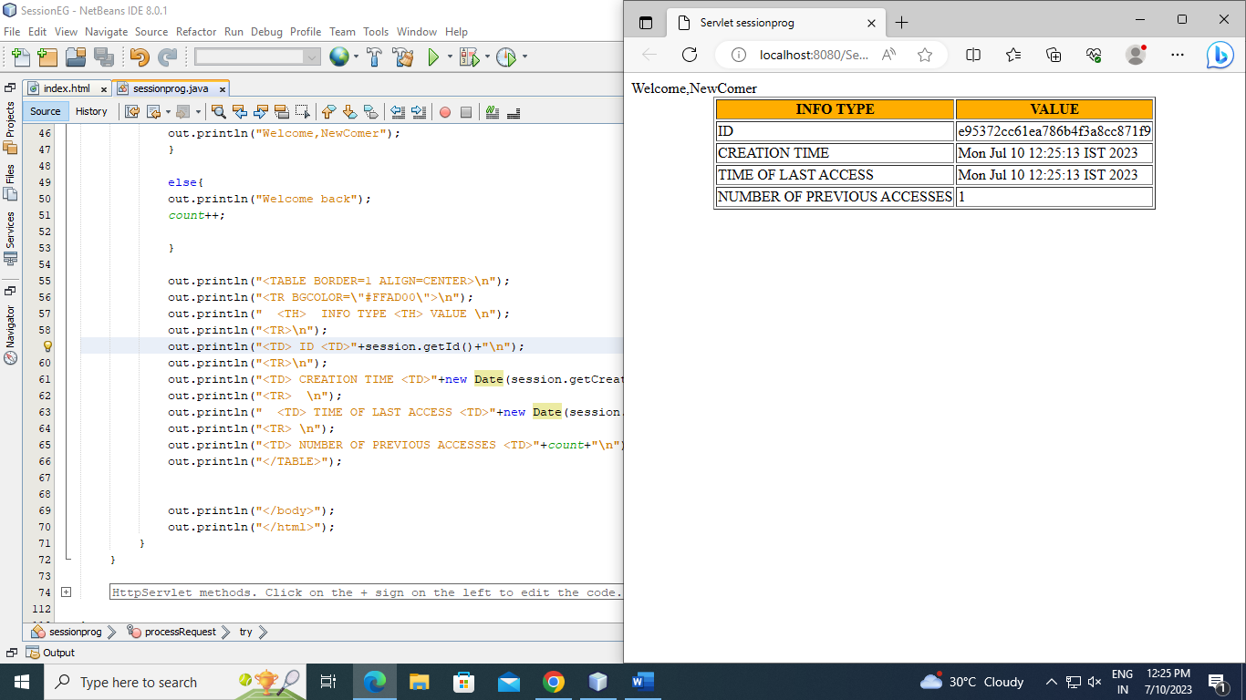

**Practical 7 – Develop a servlet question and answer application using database**

**Index.html**

<html>

<head>

<title>TODO supply a title</title>

<meta charset="UTF-8">

<meta name="viewport" content="width=device-width, initial-scale=1.0">

<style>

form {

background-color: #9b98cf;

width: 700px;

border: 5px;

padding: 25px 50px 20px 30px;

margin: auto;

border-style: inset;

}

input[type="submit"]

{

border-radius: 12px

}

</style>

</head>

<body>

<form action="servlet" method="post">

<div>

<h3>Answer the Following : </h3><br>

Q1 who is the current prime minister of India ?<br><br>

<input type="radio" name="q1" value="Narendra Modi">Narendra Modi<br>

<input type="radio" name="q1" value="Amit shah">Amit shah<br>

<input type="radio" name="q1" value="Rinku singh">Rinku singh<br>

<input type="radio" name="q1" value="Ramdayal sharma">Ramdayal sharma<br><br>

Q2 who is the current president of India ?<br><br>

<input type="radio" name="q2" value="Om jagtap">Om jagtap<br>

<input type="radio" name="q2" value="Saurav kedar">Saurav kedar<br>

<input type="radio" name="q2" value="Droupadi Murmu">Droupadi Murmu<br>

<input type="radio" name="q2" value="ram yadav">ram yadav<br><br>

Q3)What is the natural satellite of earth?<br><br>

<input type="radio" name="q3" value="Sun">Sun<br>

<input type="radio" name="q3" value="Moon">Moon<br>

<input type="radio" name="q3" value="Saturn">Sun<br>

<input type="radio" name="q3" value="Mars">Mars<br><br>

Q4)India's first atomic reactor was?<br><br>

<input type="radio" name="q4" value="Zerlina">Zerlina<br>

<input type="radio" name="q4" value="Dhruva">Dhruva<br>

<input type="radio" name="q4" value="Apsara">Apsara<br>

<input type="radio" name="q4" value="Kamini">Kamini<br><br>

Q5)How many days are there in a week?<br><br>

<input type="radio" name="q5" value="fourdays">four days<br>

<input type="radio" name="q5" value="sixdays">six days<br>

<input type="radio" name="q5" value="sevendays">seven days<br>

<input type="radio" name="q5" value="fivedays">five days<br><br>

Q6)India lies in which continent?<br><br>

<input type="radio" name="q6" value="asia">asia<br>

<input type="radio" name="q6" value="australia">australia<br>

<input type="radio" name="q6" value="antarctica">antarctica<br>

<input type="radio" name="q6" value="europe">europe<br><br>

Q7)Which is the largest state by area in India?<br><br>

<input type="radio" name="q7" value="Madhya Pradesh">Madhya Pradesh<br>

<input type="radio" name="q7" value="Rajasthan">Rajasthan<br>

<input type="radio" name="q7" value="Maharashtra">Maharashtra<br>

<input type="radio" name="q7" value="Uttar Pradesh">Uttar Pradesh<br><br>

Q8)Which is the smallest state by area in India?<br><br>

<input type="radio" name="q8" value="Sikkim">Sikkim<br>

<input type="radio" name="q8" value="Nagaland">Nagaland<br>

<input type="radio" name="q8" value="Goa">Goa<br>

<input type="radio" name="q8" value="Tripura">Tripura<br><br>

Q9)Which city is also called as Pink City in India?<br><br>

<input type="radio" name="q9" value="Udaipur">Udaipur<br>

<input type="radio" name="q9" value="Jaipur">Jaipur<br>

<input type="radio" name="q9" value="Jaisalmer">Jaisalmer<br>

<input type="radio" name="q9" value="Jodhpur">Jodhpur<br><br>

Q10)Who is the first Indian chess grandmaster?<br><br>

<input type="radio" name="q10" value="Viswanathan Anand">Viswanathan Anand<br>

<input type="radio" name="q10" value="Nihal Sarin">Nihal Sarin<br>

<input type="radio" name="q10" value="S.L. Narayanan">S.L. Narayanan<br>

<input type="radio" name="q10" value="Pravin Thipsay">Pravin Thipsay<br><br>

<input type="submit" value="Submit">

</div>

</form>

</body>

</html>

**servlet.java –**

import java.io.IOException;

import java.io.PrintWriter;

import java.sql.Connection;

import java.sql.DriverManager;

import java.sql.ResultSet;

import java.sql.SQLException;

import java.sql.Statement;

import java.util.logging.Level;

import java.util.logging.Logger;

import javax.servlet.ServletException;

import javax.servlet.annotation.WebServlet;

import javax.servlet.http.HttpServlet;

import javax.servlet.http.HttpServletRequest;

import javax.servlet.http.HttpServletResponse;

@WebServlet(urlPatterns = {"/servlet"})

public class servlet extends HttpServlet {

static int count = 0;

protected void processRequest(HttpServletRequest request, HttpServletResponse response)

throws ServletException, IOException {

response.setContentType("text/html;charset=UTF-8");

try (PrintWriter out = response.getWriter()) {

out.println("<!DOCTYPE html>");

out.println("<html>");

out.println("<head>");

out.println("<title>Servlet QA</title>");

out.println("</head>");

out.println("<body>");

String q1= request.getParameter("q1");

String q2= request.getParameter("q2");

String q3= request.getParameter("q3");

String q4= request.getParameter("q4");

String q5= request.getParameter("q5");

String q6= request.getParameter("q6");

String q7= request.getParameter("q7");

String q8= request.getParameter("q8");

String q9= request.getParameter("q9");

String q10= request.getParameter("q10");

Connection con = DriverManager.getConnection("jdbc:derby://localhost:1527/tyit","tyit","tyit");

Statement st =con.createStatement();

ResultSet rs= st.executeQuery("select * from QA");

while(rs.next())

{

if(q1.equals(rs.getString(2)))

{

count++;

}

if(q2.equals(rs.getString(2)))

{

count++;

}

if(q3.equals(rs.getString(2)))

{

count++;

}

if(q4.equals(rs.getString(2)))

{

count++;

}

if(q5.equals(rs.getString(2)))

{

count++;

}

if(q6.equals(rs.getString(2)))

{

count++;

}

if(q7.equals(rs.getString(2)))

{

count++;

}

if(q8.equals(rs.getString(2)))

{

count++;

}

if(q9.equals(rs.getString(2)))

{

count++;

}

if(q10.equals(rs.getString(2)))

{

count++;

}

}

out.print("your score "+count);

out.println("</body>");

out.println("</html>");

} catch (SQLException ex) {

Logger.getLogger(servlet.class.getName()).log(Level.SEVERE, null, ex);

}

}

Table-

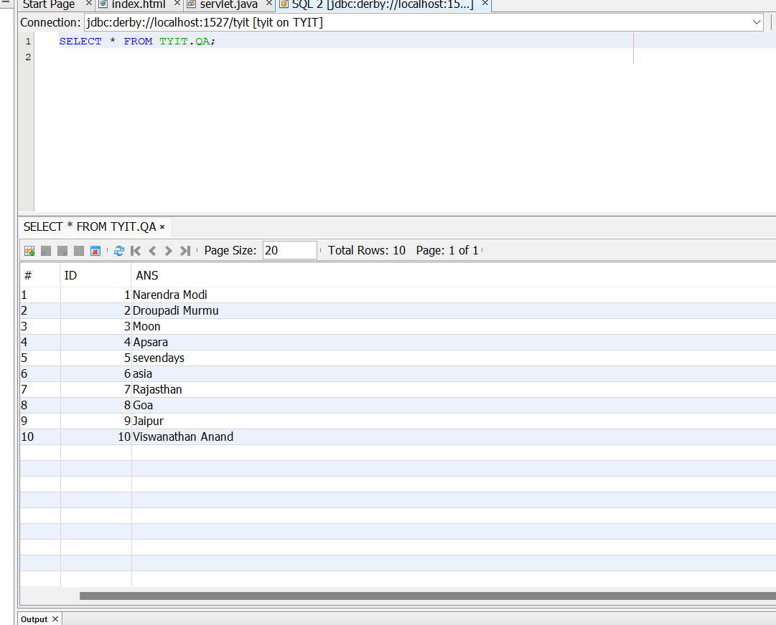

Output –

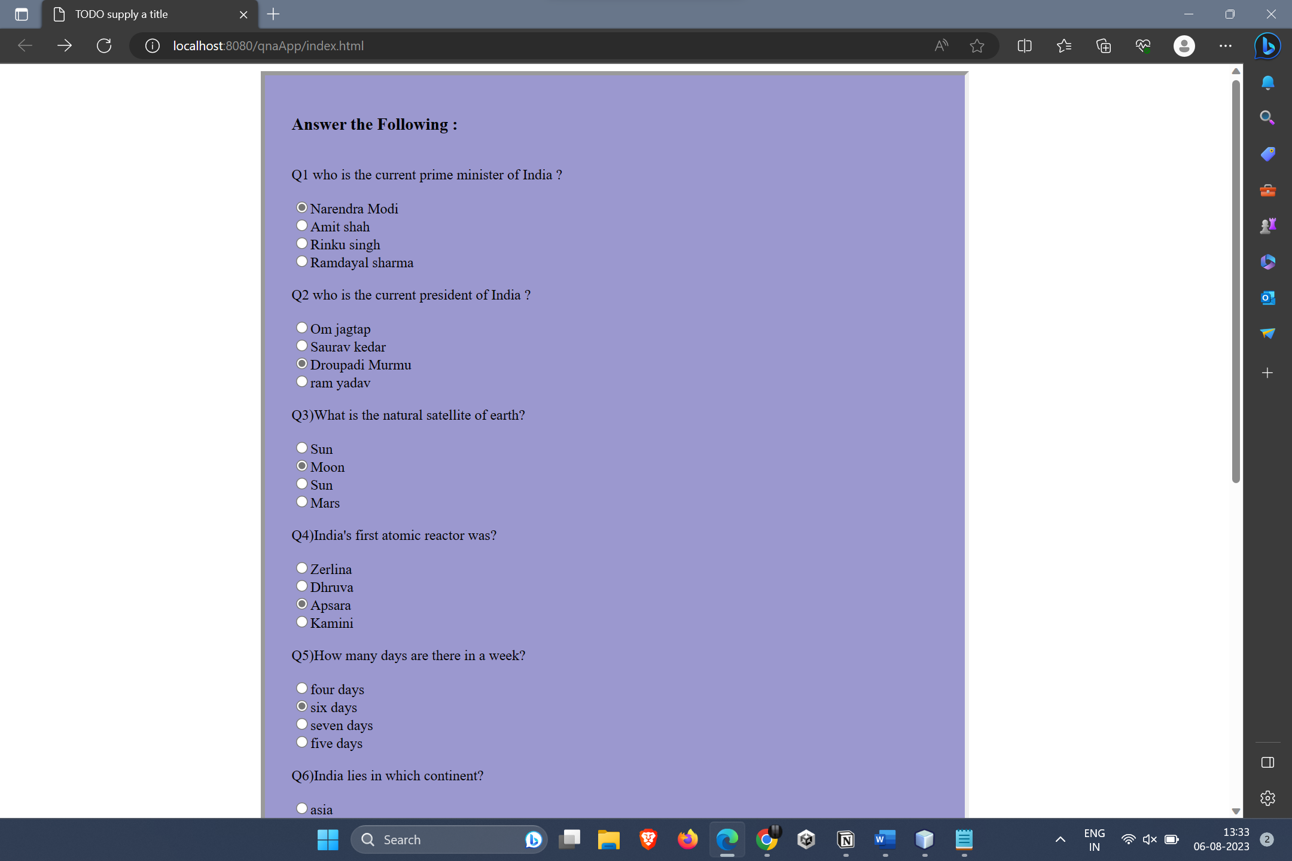

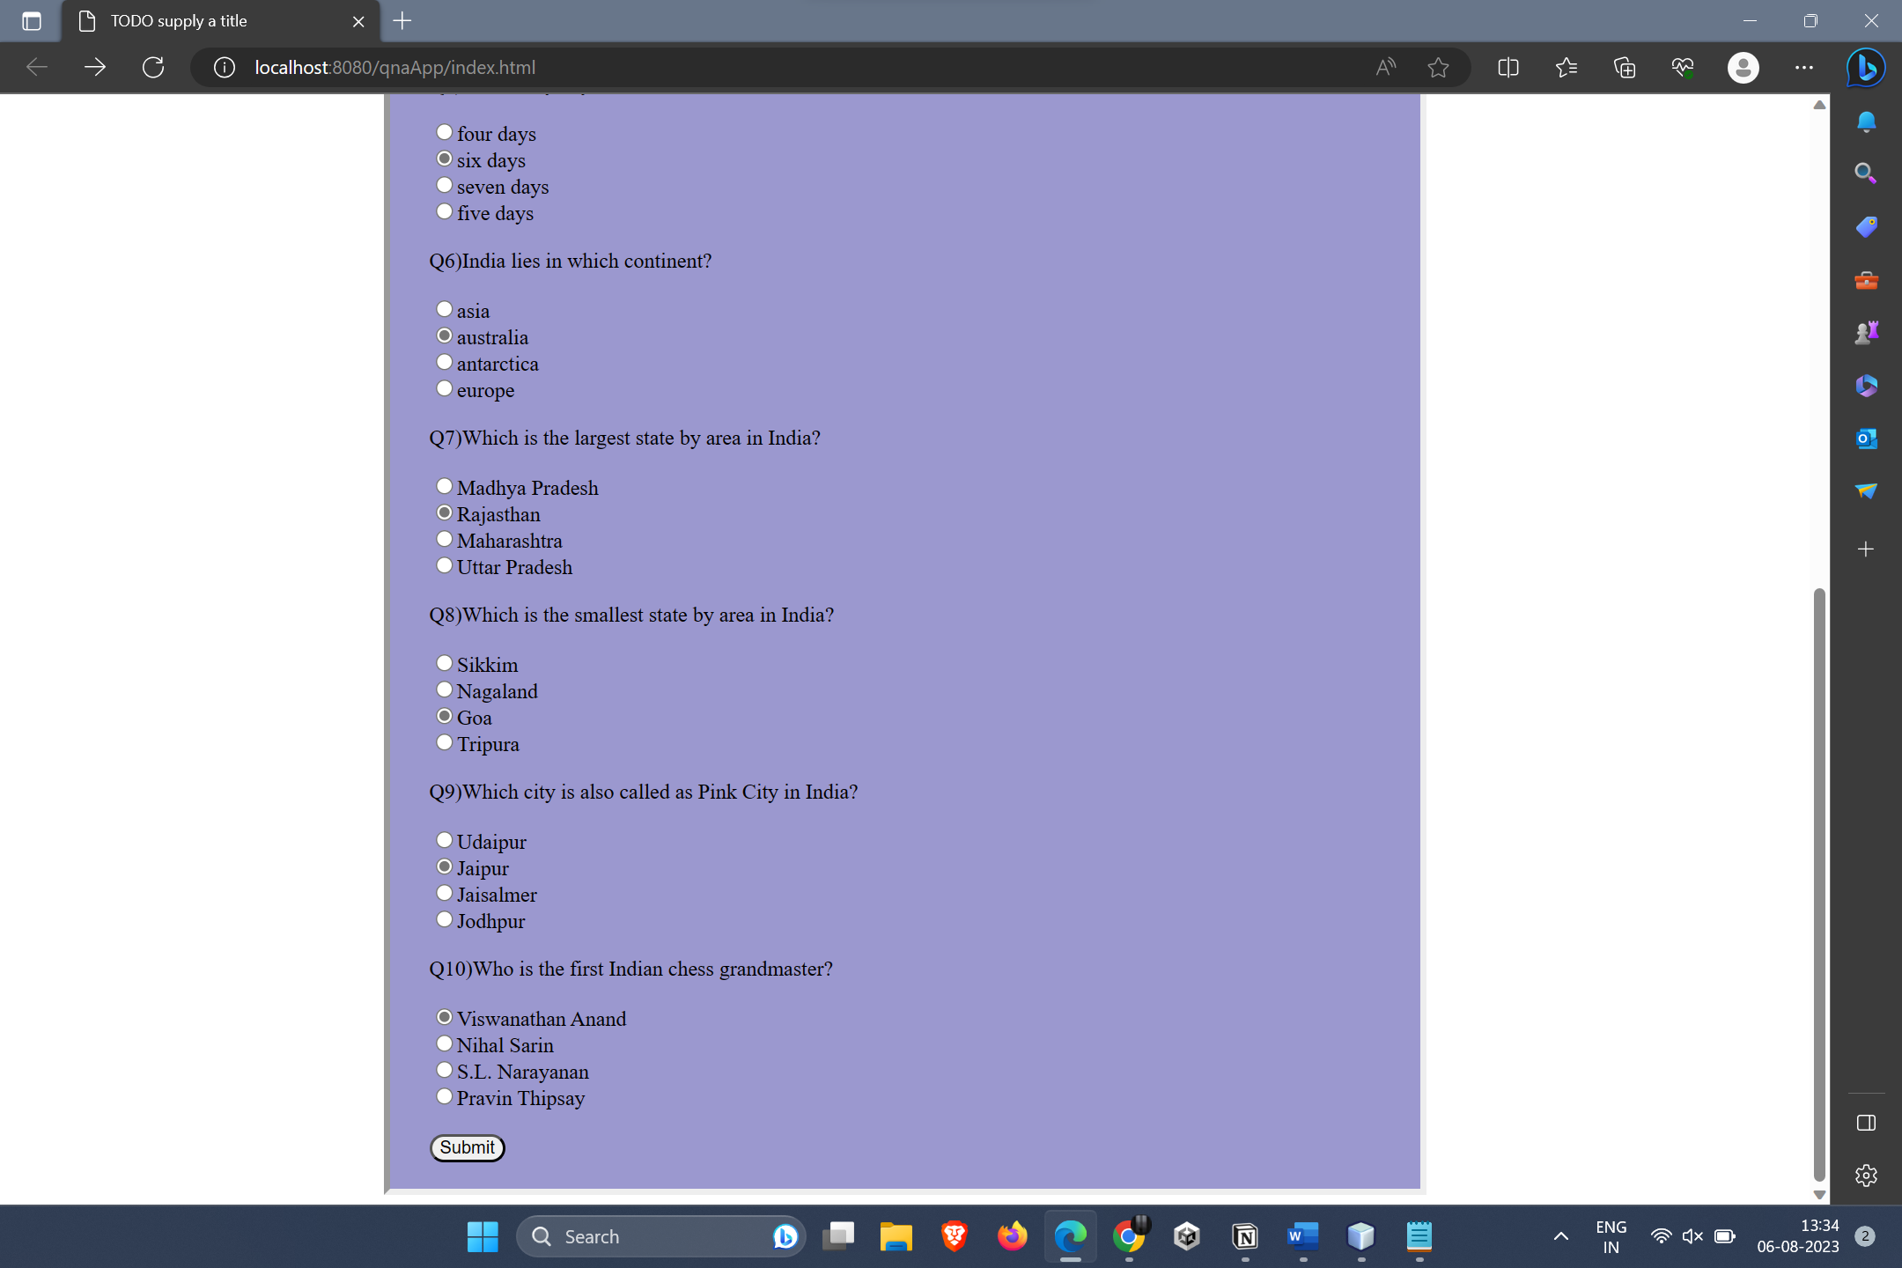

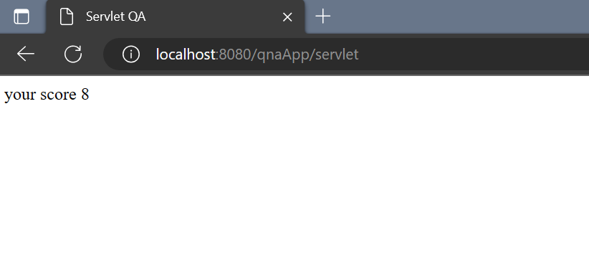

**Practical 08– Create a registration and login JSP application to register and authenticate the user based on username and password using JDBC.**

**Index.html**

<html>

<head>

<title>TODO supply a title</title>

<meta charset="UTF-8">

<meta name="viewport" content="width=device-width, initial-scale=1.0">

</head>

<body>

<form action='database.jsp' method='post'>

<h3>Registration Form</h3>

Student ID

<input type="number" name="s1" ><br><br>

Username

<input type="text" name="u1" > <br><br>

<label>Password</label>

<input type="password" id="pass" name="p1" ><br><br>

<label>Email</label>

<input type="email" id="email" name="e1" ><br><br>

Gender

<input type="radio" name="g1" value="Male"/>Male

<input type="radio" name="g1" value="Female"/>Female

<input type="radio" name="g1" value="Others"/>Other<br><br>

<input type="submit" value="Register">

</form>

</body></html>

**Database.jsp**

<%@page import="java.io.PrintWriter"%>

<%@page import="java.util.logging.Logger"%>

<%@page import="java.util.logging.Level"%>

<%@page import="java.sql.SQLException"%>

<%@page import="java.sql.Statement"%>

<%@page import="java.sql.DriverManager"%>

<%@page import="java.sql.Connection"%>

<%@page contentType="text/html" pageEncoding="UTF-8"%>

<!DOCTYPE html>

<html>

<head>

<meta http-equiv="Content-Type" content="text/html; charset=UTF-8">

<title>JSP Page</title>

</head>

<body>

<%

try{

int a= Integer.parseInt(request.getParameter("s1"));

String b= request.getParameter("u1");

String c=request.getParameter("p1");

String d=request.getParameter("e1");

String e=request.getParameter("g1");

Connection con = DriverManager.getConnection("jdbc:derby://localhost:1527/bhavans", "bhavans", "bhavans");

Statement st = con.createStatement();

st.executeUpdate("insert into STUDENT values("+a+",'"+b+"','"+c+"','"+d+"','"+e+"')");

out.println("Registered<br><br>");

}

catch(Exception e){

out.println(e);

}

%>

<a href="login.html">Login Here</a>

</body>

</html>

**Output:**

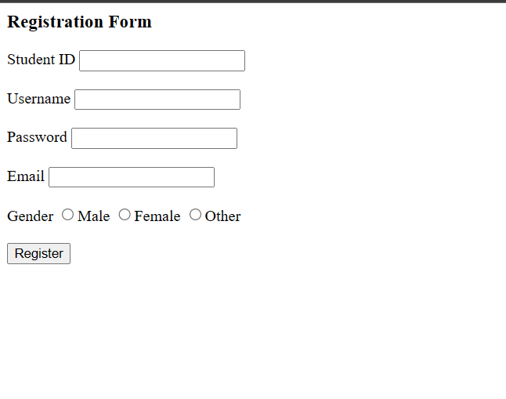

**Practical 9 – Develop a simple JSP application to pass values from one page to another**

**Index.html-**

<html>

<head>

<title>TODO supply a title</title>

<meta charset="UTF-8">

<meta name="viewport" content="width=device-width, initial-scale=1.0">

</head>

<body>

<form action="jspIm.jsp" method="POST">

ID : <input type="number" name="id"><br>

Name : <input type="text" name="uname"><br>

Salary : <input type="number" name="sal"><br>

<input type="submit" value="submit">

</form>

</body>

</html>

**user.jsp-**

<html>

<head>

<meta http-equiv="Content-Type" content="text/html; charset=UTF-8">

<title>JSP Page</title>

<style>

table,th,td{

border :2px solid burlywood;

border-collapse:collapse;

background-color: #85baff;

}

td{

padding: 10px;

}

table.center{

margin-left:auto;

margin-right:auto;

}

body{

padding-top: 100px;

}

</style>

</head>

<body>

<%

int id=Integer.parseInt(request.getParameter("id"));

String name=request.getParameter("uname");

int sal=Integer.parseInt(request.getParameter("sal"));

%>

<table class ="center">

<tr>

<th>ID</th>

<th>Name</th>

<th>Salary</th>

</tr>

<tr>

<td>

<%out.println(id);%>

</td>

<td>

<%out.println(name);%>

</td>

<td>

<%out.println(sal);%>

</td>

</tr>

</table>

</body> </html>

**Output-**

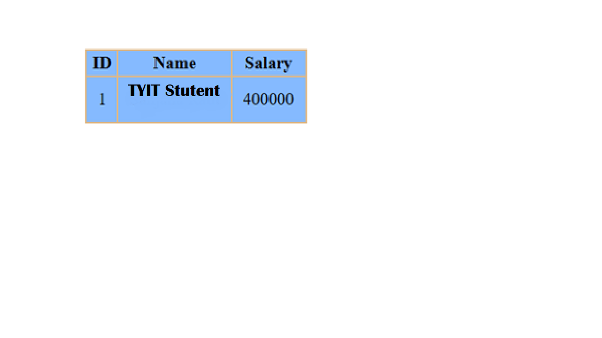

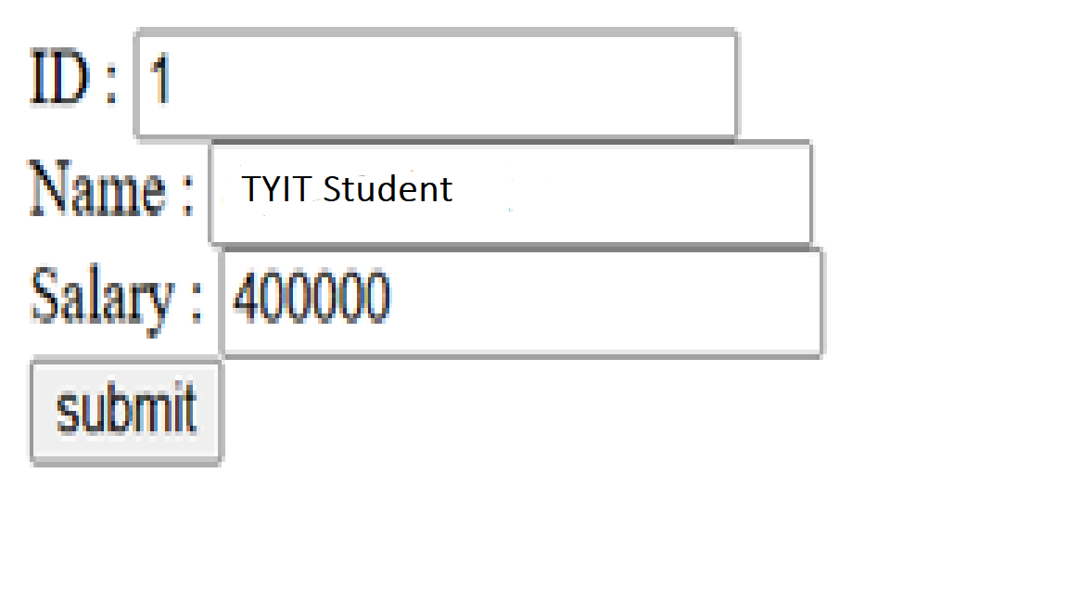

**Practical 10 :- Create a servlet that updates the Employee record using database**

**Index.html -**

<html>

<head>

<title>TODO supply a title</title>

<meta charset="UTF-8">

<meta name="viewport" content="width=device-width, initial-scale=1.0">

<style>

form {

align-items: center ;

justify-content: center;

background-color: #98c9ed;

width: 300px;

border: 10px;

border-color: #98b78e;

padding: 5px 50px 20px 30px;

margin: auto;

margin-top: 250px;

border-style: outset;

}

</style>

</head>

<body>

<form method="POST" action="preServ">

<div>

<h2>Update the table student using prepared statement</h2

ID : <input type="text" name="t1"><br><br>

NAME : <input type="text" name="t2">

<br><br>

<input type="submit" value="UPDATE">

</div>

</form>

</body>

</html>

**preServ.java -**

import java.io.IOException;

import java.io.PrintWriter;

import java.sql.Connection;

import java.sql.DriverManager;

import java.sql.PreparedStatement;

import java.sql.SQLException;

import java.util.logging.Level;

import java.util.logging.Logger;

import javax.servlet.ServletException;

import javax.servlet.http.HttpServlet;

import javax.servlet.http.HttpServletRequest;

import javax.servlet.http.HttpServletResponse;

protected void processRequest(HttpServletRequest request, HttpServletResponse response)

throws ServletException, IOException {

response.setContentType("text/html;charset=UTF-8");

try (PrintWriter out = response.getWriter()) {

out.println("<!DOCTYPE html>");

out.println("<html>");

out.println("<head>");

out.println("<title>Servlet preServ</title>");

out.println("</head>");

out.println("<body>");

int id = Integer.parseInt(request.getParameter("t1"));

String name=request.getParameter("t2");

Connection con = DriverManager.getConnection("jdbc:derby://localhost:1527/tyit", "tyit", "tyit");

PreparedStatement pstmt = con.prepareStatement("Update demo set name= ? where id = ?");

pstmt.setString(1,name);

pstmt.setInt(2, id);

int ans=pstmt.executeUpdate();

if(ans==1)

{

out.println("<h1>Record updated</h1>");

}

else{

out.println("<h1>Not updated</h1>");

}

out.println("<h1>Connected</h1>");

out.println("</body>");

out.println("</html>");

} catch (SQLException ex) {

Logger.getLogger(preServ.class.getName()).log(Level.SEVERE, null, ex);

}

}

**Table –**

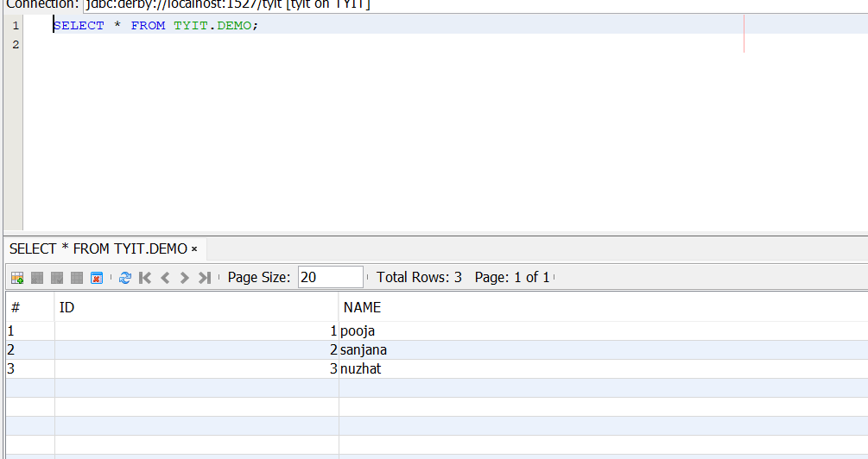

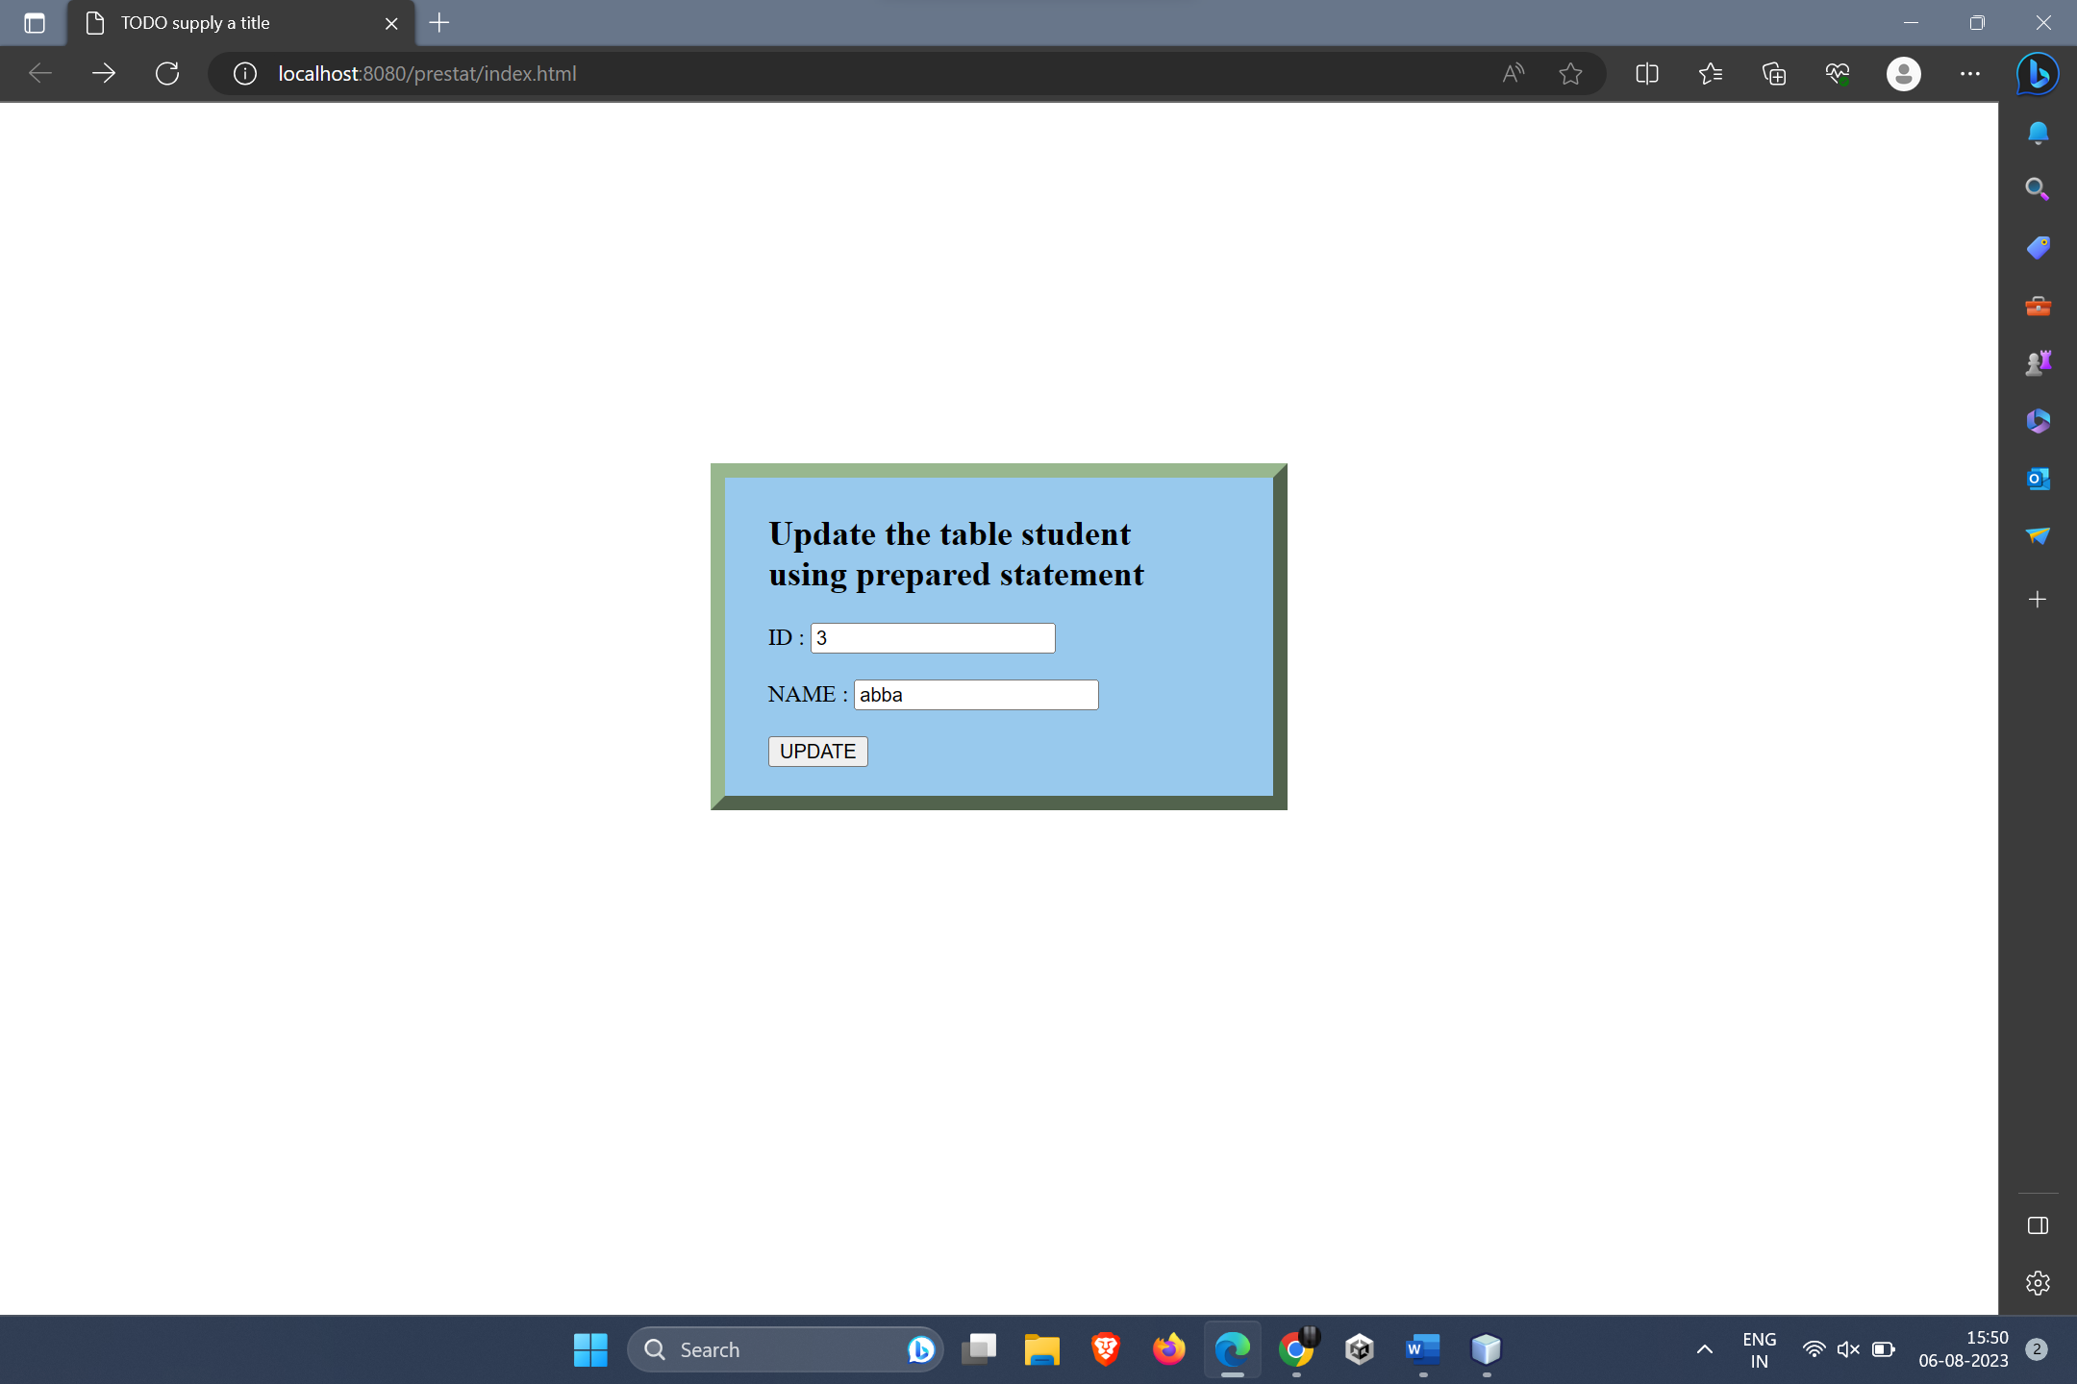

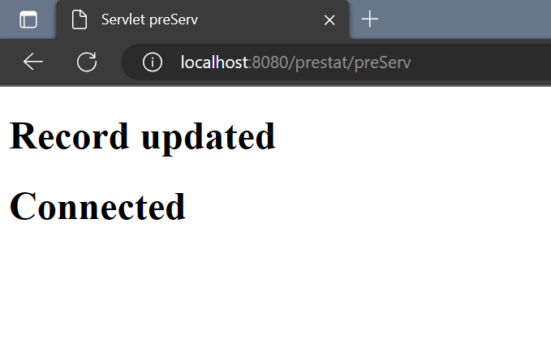

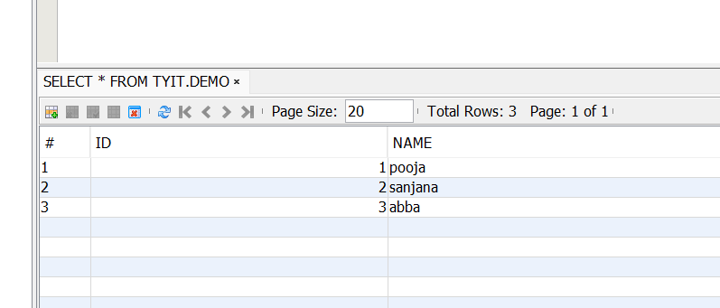

**Practical 11: Create a JSP application to demonstrate the use of Expression Language.**

**Index.html**

<html>

<head>

<title>TODO supply a title</title>

<meta charset="UTF-8">

<meta name="viewport" content="width=device-width, initial-scale=1.0">

</head>

<body>

<form method="post" action="newjsp.jsp">

name:<input type="text" name="t1"><br><br>

num1:<input type="text" name="t2"><br>

num2:<input type="text" name="t3"><br>

<input type="submit" value="submit">

</form>

</body>

</html>

**newjsp.jsp**

<%@page contentType="text/html" pageEncoding="UTF-8"%>

<!DOCTYPE html>

<html>

<head>

<meta http-equiv="Content-Type" content="text/html; charset=UTF-8">

<title>JSP Page</title>

</head>

<body>

<h1>Hello ${param.t1}</h1>

<h2>addition:${param.t2+param.t3}</h2>

**</body>**

**</html>**

**Output:**

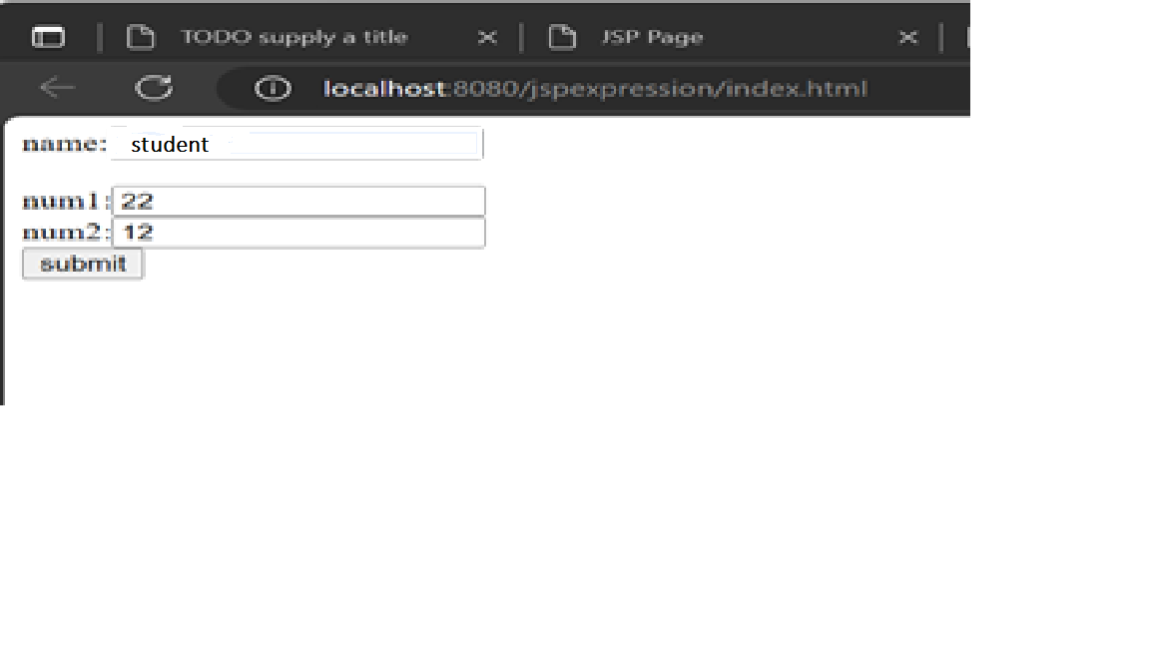

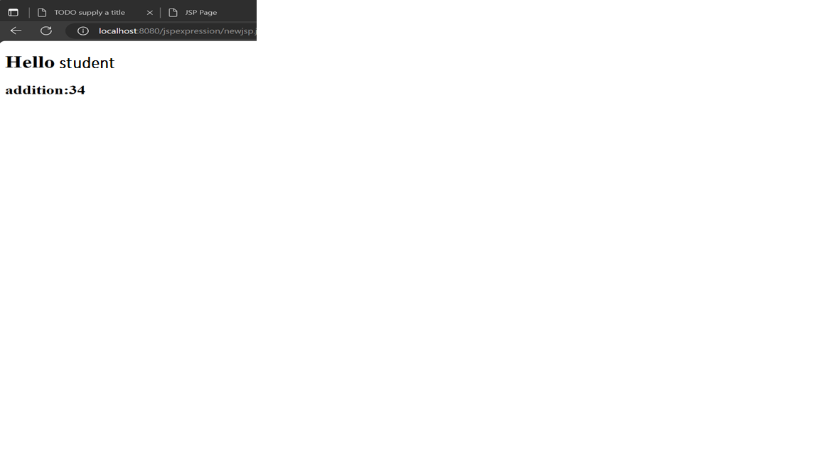-

## **Practical 12 – Create a JSP application to demonstrate the use of JSTL(for each)**

Jstl.jsp:-

<%@page contentType="text/html" pageEncoding="UTF-8"%>

<%@ taglib uri="http://java.sun.com/jsp/jstl/core" prefix="c" %>

<%@ taglib uri="http://java.sun.com/jsp/jstl/functions" prefix="fn" %>

<!DOCTYPE html>

<html>

<head>

<meta http-equiv="Content-Type" content="text/html; charset=UTF-8">

<title>JSP Page</title>

</head>

<body>

<c:set var="demo" value="Welcome to jstl"/>

${fn:toLowerCase(demo)}

${fn:toUpperCase(demo)}<br/><br/>

<c:forEach var="j" begin="1" end="3">

Welcome to jstl <c:out value="${j}"/><p>

</c:forEach>

</body>

</html>

**OUTPUT:**

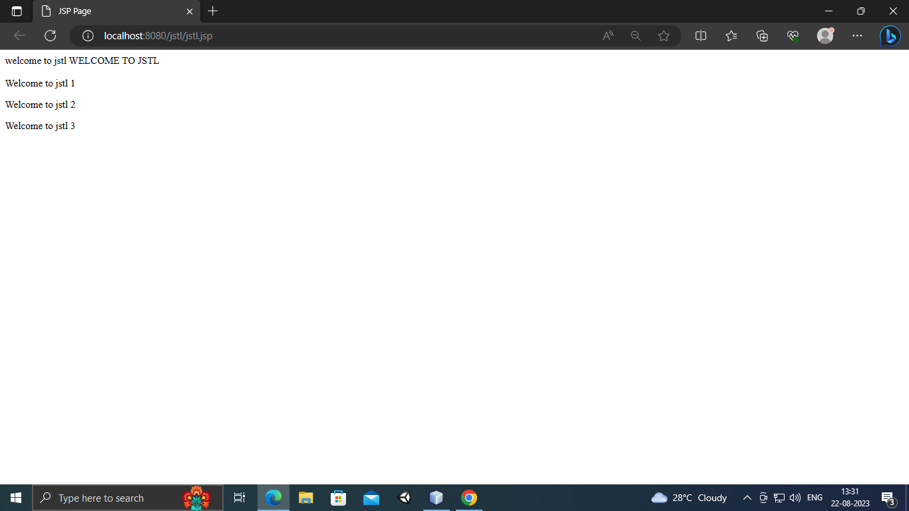

**Practical 13 : Create a calculator using EJB**

**Index.html**

<html>

<head>

<title>TODO supply a title</title>

<meta charset="UTF-8">

<meta name="viewport" content="width=device-width, initial-scale=1.0">

</head>

<body>

<form action="NewServlet" method="" >

first number=<input type="text" name="t1"> <br>

second number=<input type="text" name="t2"> <br>

<input type="submit" value="Addition">

</form>

</body>

</html>

**Calcbean.java**

package sessionbean;

import javax.ejb.Stateless;

@Stateless

public class calcbean implements calcbeanLocal {

@Override

public Integer addition(int a, int b) {

return (a+b);

}

}

**calcbeanLocal.java**

package sessionbean;

import javax.ejb.Local;

@Local

public interface calcbeanLocal {

Integer addition(int a, int b);

}

**NewServlet.java**

package sessionbean;

import java.io.IOException;

import java.io.PrintWriter;

import javax.ejb.EJB;

import javax.servlet.ServletException;

import javax.servlet.http.HttpServlet;

import javax.servlet.http.HttpServletRequest;

import javax.servlet.http.HttpServletResponse;

public class NewServlet extends HttpServlet {

@EJB

private calcbeanLocal calcbean;

protected void processRequest(HttpServletRequest request, HttpServletResponse response)

throws ServletException, IOException {

response.setContentType("text/html;charset=UTF-8");

try (PrintWriter out = response.getWriter()) {

out.println("<!DOCTYPE html>");

out.println("<html>");

out.println("<head>");

out.println("<title>Servlet NewServlet</title>");

out.println("</head>");

out.println("<body>");

int a=Integer.parseInt(request.getParameter("t1"));

int b=Integer.parseInt(request.getParameter("t2"));

out.println("<h1>Result:"+calcbean.addition(a,b)+"</h1>");

out.println("</body>");

out.println("</html>");

}

}

@Override

protected void doGet(HttpServletRequest request, HttpServletResponse response)

throws ServletException, IOException {

processRequest(request, response);

}

@Override

protected void doPost(HttpServletRequest request, HttpServletResponse response)

throws ServletException, IOException {

processRequest(request, response);

}

@Override

public String getServletInfo() {

return "Short description";

}

}

**Output:**

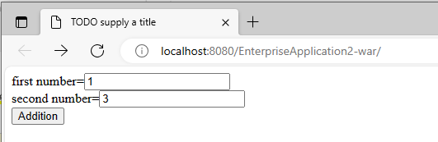

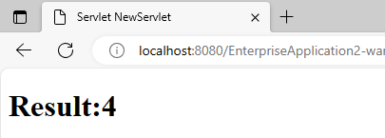

**Practical 14: Create a Currency Convereter Application using EJB**

**Index.html**

<html>

<head>

<title>TODO supply a title</title>

<meta charset="UTF-8">

<meta name="viewport" content="width=device-width, initial-scale=1.0">

</head>

<body>

<form action ="rtd">

<h1> Rupees To Dollar</h1>

Enter amount :- <input type ="text" name="num"> <br>

<input type="submit" value="Convert">

</form>

</body>

</html>

**Convert.java (EJB)**

package test;

import javax.ejb.Stateless;

@Stateless

public class Convert implements ConvertLocal {

@Override

public Float rupeestodollar(float x) {

return x*83;

}

}

**ConvertLocal.java**

package test;

import javax.ejb.Local;

@Local

public interface ConvertLocal {

Float rupeestodollar(float x);

}

**rtd.java(Servlet)**

package test;

import java.io.IOException;

import java.io.PrintWriter;

import javax.ejb.EJB;

import javax.servlet.ServletException;

import javax.servlet.http.HttpServlet;

import javax.servlet.http.HttpServletRequest;

import javax.servlet.http.HttpServletResponse;

public class rtd extends HttpServlet {

@EJB

private ConvertLocal convert;

protected void processRequest(HttpServletRequest request, HttpServletResponse response)

throws ServletException, IOException {

response.setContentType("text/html;charset=UTF-8");

try (PrintWriter out = response.getWriter()) {

int num=Integer.parseInt(request.getParameter("num"));

out.println("<!DOCTYPE html>");

out.println("<html>");

out.println("<head>");

out.println("<title>Servlet rtd</title>");

out.println("</head>");

out.println("<body>");

out.println("<h1> Rupees to Dollar " + convert.rupeestodollar(num) +"</h1>");

out.println("</body>");

out.println("</html>");

}

}

// <editor-fold defaultstate="collapsed" desc="HttpServlet methods. Click on the + sign on the left to edit the code.">

@Override

protected void doGet(HttpServletRequest request, HttpServletResponse response)

throws ServletException, IOException {

processRequest(request, response);

}

@Override

protected void doPost(HttpServletRequest request, HttpServletResponse response)

throws ServletException, IOException {

processRequest(request, response);

}

@Override

public String getServletInfo() {

return "Short description";

}// </editor-fold>

}

**Output :-**

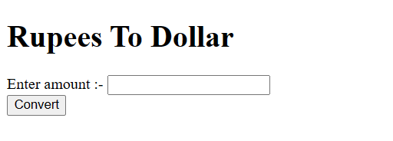

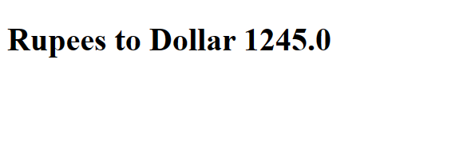

**Practical 15:- Develop a simple room reservation system using EJB.**

### Index.html

<html>

<head>

<title>TODO supply a title</title>

<meta charset="UTF-8">

<meta name="viewport" content="width=device-width, initial-scale=1.0">

</head>

<body>

<form action="RRservlet" method="post" >

Select a room Type

<input type="radio" name="r1" value="Delux">Delux

<input type="radio" name="r1" value="Super Delux">Super Delux

<input type="radio" name="r1" value="Suit">Suit<br><br>

Enter Your Name<input type="text" name="n1" ><br><br>

Enter Mobile No.<input type="text" name="m1" ><br><br>

Enter Your Address<input type="text" name="a1"><br><br>

<input type="reset" ><input type="submit" value="Book Room">

</form>

</body>

</html>

### room1.java

package roomrev;

import java.sql.Connection;

import java.sql.DriverManager;

import java.sql.PreparedStatement;

import java.sql.ResultSet;

import javax.ejb.Stateless;

@Stateless

public class room1 implements room1Local {

public room1(){}

@Override

public String roomBook(String rt, String cn, String cm, String cadd){

String msg="";

try{

Connection con = DriverManager.getConnection("jdbc:derby://localhost:1527/demo","demo","demo");

String query="select * from roombook where RoomType=? and status='Not Booked'";

PreparedStatement pst = con.prepareStatement(query);

pst.setString(1,rt);

ResultSet rs= pst.executeQuery();

if(rs.next()){

String rno=rs.getString(1);

PreparedStatement stm1 = con.prepareStatement("update roombook set cust=? where RoomId=? ");

PreparedStatement stm2 = con.prepareStatement("update roombook set mobile=? where RoomId=? ");

PreparedStatement stm3 = con.prepareStatement("update roombook set status=? where RoomId=? ");

PreparedStatement stm4 = con.prepareStatement("update ROOM set ADDRESS=? where ROOMID=? ");

stm1.setString(1,cn); stm1.setString(2,rno);

stm2.setString(1,cm); stm2.setString(2,rno);

stm3.setString(1, "Booked"); stm3.setString(2,rno);

stm4.setString(1, cadd); stm4.setString(2, rno);

stm1.executeUpdate();

stm2.executeUpdate();

stm3.executeUpdate();

stm4.executeUpdate();

msg = "Room "+rno+ "<br> Booked <br> Charges = "+rs.getString(3);

}

else{

msg = "Room "+rt+ " currently Not available";

} }

catch(Exception e){msg=""+e;}

return msg;}}

### room1Local.java –

package roomrev;

import javax.ejb.Local;

@Local

public interface room1Local {

public String roomBook(String rt, String cn, String cm, String cadd);

}

### RRServlet –

package roomrev;

import java.io.IOException;

import java.io.PrintWriter;

import javax.ejb.EJB;

import javax.servlet.ServletException;

import javax.servlet.http.HttpServlet;

import javax.servlet.http.HttpServletRequest;

import javax.servlet.http.HttpServletResponse;

public class RRServlet extends HttpServlet {

@EJB

private room1Local room1;

protected void processRequest(HttpServletRequest request, HttpServletResponse response)

throws ServletException, IOException {

response.setContentType("text/html;charset=UTF-8");

try (PrintWriter out = response.getWriter()) {

/* TODO output your page here. You may use following sample code. */

out.println("<!DOCTYPE html>");

out.println("<html>");

out.println("<head>");

out.println("<title>Servlet RRServlet</title>");

out.println("</head>");

out.println("<body>");

String rt=request.getParameter("r1");

String cn=request.getParameter("n1");

String cm=request.getParameter("m1");

String cadd=request.getParameter("a1");

String msg = room1.roomBook(rt, cn, cm,cadd);

out.println(msg);

out.println("</body>");

out.println("</html>");

}

}

**Output:**

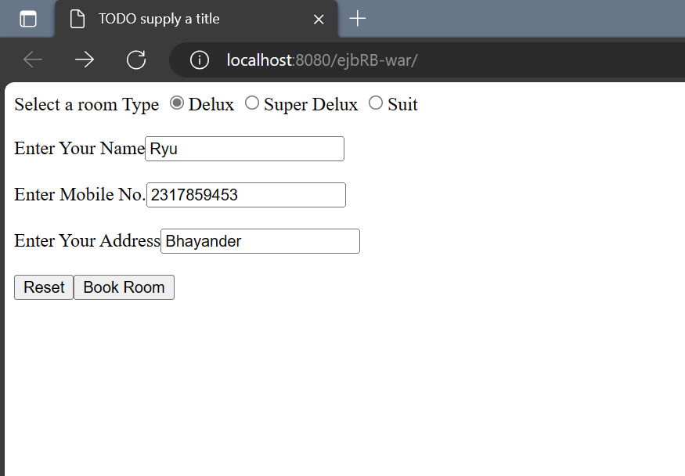

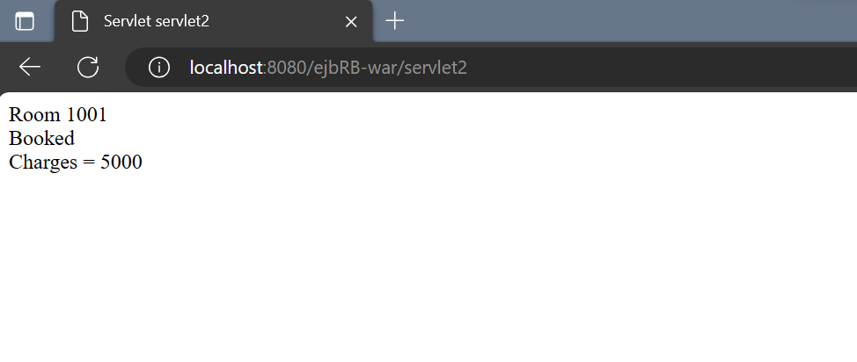

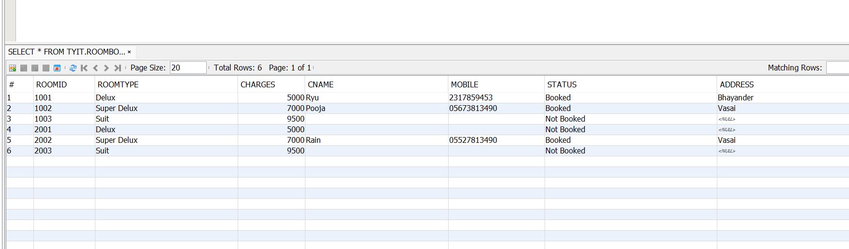

**Practical 16.:- Develop a JPA Application to demonstrate use of ORM associations.**

**employee.java**

package persist;

import java.io.Serializable;

import javax.persistence.Entity;

import javax.persistence.GeneratedValue;

import javax.persistence.GenerationType;

import javax.persistence.Id;

@Entity

public class employee implements Serializable {

private static final long serialVersionUID = 1L;

@Id

@GeneratedValue(strategy = GenerationType.AUTO)

private Long id;

private String name;

private int salary;

public Long getId() {

return id;

}

public void setId(Long id) {

this.id = id;

}

@Override

public int hashCode() {

int hash = 0;

hash += (id != null ? id.hashCode() : 0);

return hash;

}

@Override

public boolean equals(Object object) {

// TODO: Warning - this method won't work in the case the id fields are not set

if (!(object instanceof employee)) {

return false;

}

employee other = (employee) object;

if ((this.id == null && other.id != null) || (this.id != null && !this.id.equals(other.id))) {

return false;

}

return true;

}

@Override

public String toString() {

return "persist.employee[ id=" + id + " ]";

}

public String getName() {

return name;

}

public void setName(String name) {

this.name = name;

}

public int getSalary() {

return salary;

}

public void setSalary(int salary) {

this.salary = salary;

}

}

**AbstractFacade.java**

package persist;

import java.util.List;

import javax.persistence.EntityManager;

public abstract class AbstractFacade<T> {

private Class<T> entityClass;

public AbstractFacade(Class<T> entityClass) {

this.entityClass = entityClass;

}

protected abstract EntityManager getEntityManager();

public void create(T entity) {

getEntityManager().persist(entity);

}

public void edit(T entity) {

getEntityManager().merge(entity);

}

public void remove(T entity) {

getEntityManager().remove(getEntityManager().merge(entity));

}

public T find(Object id) {

return getEntityManager().find(entityClass, id);

}

public List<T> findAll() {

javax.persistence.criteria.CriteriaQuery cq = getEntityManager().getCriteriaBuilder().createQuery();

cq.select(cq.from(entityClass));

return getEntityManager().createQuery(cq).getResultList();

}

public List<T> findRange(int[] range) {

javax.persistence.criteria.CriteriaQuery cq = getEntityManager().getCriteriaBuilder().createQuery();

cq.select(cq.from(entityClass));

javax.persistence.Query q = getEntityManager().createQuery(cq);

q.setMaxResults(range[1] - range[0] + 1);

q.setFirstResult(range[0]);

return q.getResultList();

}

public int count() {

javax.persistence.criteria.CriteriaQuery cq = getEntityManager().getCriteriaBuilder().createQuery();

javax.persistence.criteria.Root<T> rt = cq.from(entityClass);

cq.select(getEntityManager().getCriteriaBuilder().count(rt));

javax.persistence.Query q = getEntityManager().createQuery(cq);

return ((Long) q.getSingleResult()).intValue();

}

}

**employeeFacade.java**

package persist;

import javax.ejb.Stateless;

import javax.persistence.EntityManager;

import javax.persistence.PersistenceContext;

@Stateless

public class employeeFacade extends AbstractFacade<employee> implements employeeFacadeLocal {

@PersistenceContext(unitName = "table-ejbPU")

private EntityManager em;

@Override

protected EntityManager getEntityManager() {

return em;

}

public employeeFacade() {

super(employee.class);

}

}

**employeeFacadeLocal.java**

package persist;

import javax.ejb.Stateless;

import javax.persistence.EntityManager;

import javax.persistence.PersistenceContext;

@Stateless

public class employeeFacade extends AbstractFacade<employee> implements employeeFacadeLocal {

@PersistenceContext(unitName = "table-ejbPU")

private EntityManager em;

@Override

protected EntityManager getEntityManager() {

return em;

}

public employeeFacade() {

super(employee.class);

}

}

**Index.html**

<html>

<head>

<title>TODO supply a title</title>

<meta charset="UTF-8">

<meta name="viewport" content="width=device-width, initial-scale=1.0">

</head>

<body>

<center>

<h1> REGISTRATION </h1>

<form action="NewServlet">

Name:<input type ="text" name="t1"><br>

Salary: <input type ="text" name="t2"><br>

<input type="submit" value="ADD">

</center>

</form>

</body></html>

**NewServlet.java**

package persist;

import java.io.IOException;

import java.io.PrintWriter;

import javax.ejb.EJB;

import javax.servlet.ServletException;

import javax.servlet.http.HttpServlet;

import javax.servlet.http.HttpServletRequest;

import javax.servlet.http.HttpServletResponse;

public class NewServlet extends HttpServlet {

@EJB

private employeeFacadeLocal employeeFacade;

protected void processRequest(HttpServletRequest request, HttpServletResponse response)

throws ServletException, IOException {

response.setContentType("text/html;charset=UTF-8");

try (PrintWriter out = response.getWriter()) {

/* TODO output your page here. You may use following sample code. */

out.println("<!DOCTYPE html>");

out.println("<html>");

out.println("<head>");

out.println("<title>Servlet NewServlet</title>");

out.println("</head>");

out.println("<body>");

String n = request.getParameter("t1");

int s = Integer.parseInt(request.getParameter("t2"));

employee obj=new employee();

obj.setName(n);

obj.setSalary(s);

out.println("<h1>Record Added Sucessfully</h1");

employeeFacade.create(obj);

out.println("<h1>Record Added Sucessfully</h1");

out.println("</body>");

out.println("</html>");

}

}

// <editor-fold defaultstate="collapsed" desc="HttpServlet methods. Click on the + sign on the left to edit the code.">

@Override

protected void doGet(HttpServletRequest request, HttpServletResponse response)

throws ServletException, IOException {

processRequest(request, response);

}

@Override

protected void doPost(HttpServletRequest request, HttpServletResponse response)

throws ServletException, IOException {

processRequest(request, response);

}

@Override

public String getServletInfo() {

return "Short description";

}// </editor-fold>

}

**Output:**

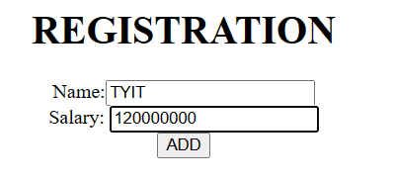

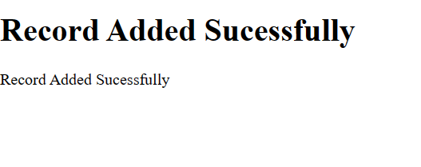

**Practical 17 : Develop a simple application using hibernate**

1. **Index.html**

<html>

<head>

<title>TODO supply a title</title>

<meta charset="UTF-8">

<meta name="viewport" content="width=device-width, initial-scale=1.0">

</head>

<body>

<div>TODO write content</div>

</body>

</html>

1. **Hibernate.cfg.xml:**

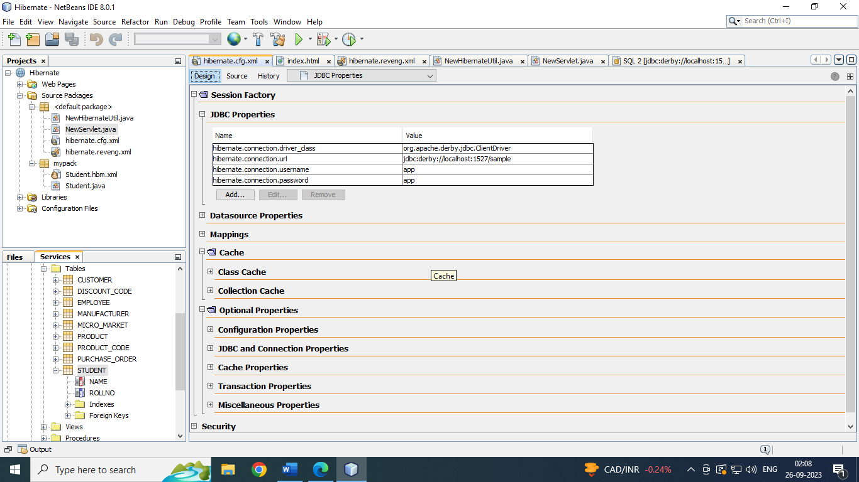

1. **hibernate.revenge.xml:**

<?xml version="1.0" encoding="UTF-8"?>

<!DOCTYPE hibernate-reverse-engineering PUBLIC "-//Hibernate/Hibernate Reverse Engineering DTD 3.0//EN" "http://hibernate.sourceforge.net/hibernate-reverse-engineering-3.0.dtd">

<hibernate-reverse-engineering>

<schema-selection match-schema="APP"/>

<table-filter match-name="STUDENT"/>

</hibernate-reverse-engineering>

1. **NewhibernateUtil.java**

import org.hibernate.cfg.AnnotationConfiguration;

import org.hibernate.SessionFactory;

/**

* Hibernate Utility class with a convenient method to get Session Factory

* object.

*

* @author LAB-PC10

*/

public class NewHibernateUtil {

private static final SessionFactory sessionFactory;

static {

try {

// Create the SessionFactory from standard (hibernate.cfg.xml)

// config file.

sessionFactory = new AnnotationConfiguration().configure().buildSessionFactory();

} catch (Throwable ex) {

// Log the exception.

System.err.println("Initial SessionFactory creation failed." + ex);

throw new ExceptionInInitializerError(ex);

}

}

public static SessionFactory getSessionFactory() {

return sessionFactory;

}

}

**5. NewServlet.java:**

import java.io.IOException;

import java.io.PrintWriter;

import javax.servlet.ServletException;

import javax.servlet.annotation.WebServlet;

import javax.servlet.http.HttpServlet;

import javax.servlet.http.HttpServletRequest;

import javax.servlet.http.HttpServletResponse;

import org.hibernate.Session;

import org.hibernate.SessionFactory;

import org.hibernate.Transaction;

/**

*

* @author LAB-PC10

*/

@WebServlet(urlPatterns = {"/NewServlet"})

public class NewServlet extends HttpServlet {

/**

* Processes requests for both HTTP <code>GET</code> and <code>POST</code>

* methods.

*

* @param request servlet request

* @param response servlet response

* @throws ServletException if a servlet-specific error occurs

* @throws IOException if an I/O error occurs

*/

protected void processRequest(HttpServletRequest request, HttpServletResponse response)

throws ServletException, IOException {

response.setContentType("text/html;charset=UTF-8");

try (PrintWriter out = response.getWriter()) {

/* TODO output your page here. You may use following sample code. */

out.println("<!DOCTYPE html>");

out.println("<html>");

out.println("<head>");

out.println("<title>Servlet NewServlet</title>");

out.println("</head>");

out.println("<body>");

out.println("<h1>Servlet NewServlet at " + request.getContextPath() + "</h1>");

SessionFactory sf;

Transaction t;

Session s;

sf=NewHibernateUtil.getSessionFactory();

s=sf.openSession();

t=s.getTransaction();

t.begin();

mypack.Student st1=new mypack.Student("Aditi",2);

s.save(st1);

t.commit();

s.close();

out.println("</body>");

out.println("</html>");

}

}

**Output:**

